Comment: Always Stretch To Your Comfort

Fingers & hand open/close Stretch wrist flexors with straight arm Stretch wrist flexors with straight arm
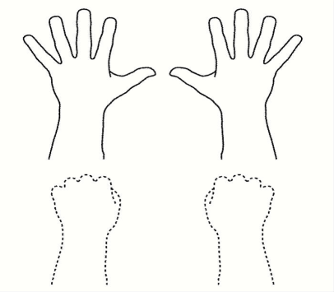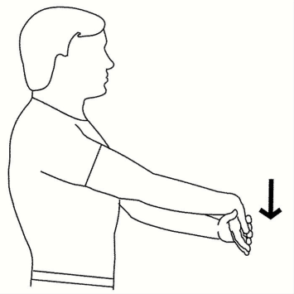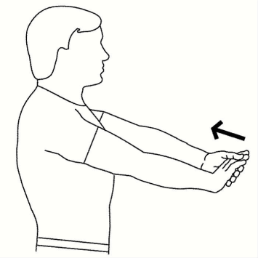
Perform 1 set of 5 Repetitions, 4 times a day Perform 1 set of 2 Repetitions, twice a day Perform 1 set of 2 Repetitions, twice a day
Perform 1 repetition every 4 Seconds Hold exercise for 20 Seconds. Hold exercise for 20 Seconds

Stretch wrist extensors straight arm Sun Salute – Shoulder Retract-Thoracic Ext Stretch Rhomboids
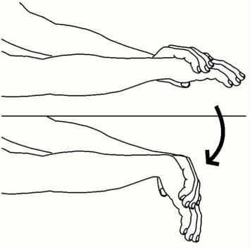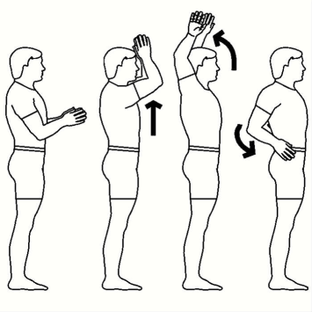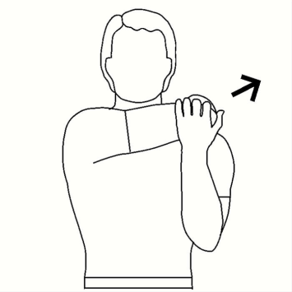
Perform 1 set of 1 Repetitions, twice a day Perform 1 set of 5 Repetitions, twice a day Perform 1 set of 2 Repetitions, twice a day
Hold exercise for 20 Seconds. Perform 1 repetition every 4 Seconds. Hold exercise for 20 Seconds

Stretch both wrist flexors (overhead) Both shoulder blade retract in sitting Both shoulder elevation/retract (shoulder rolls)
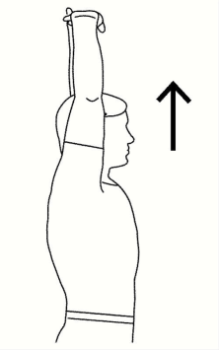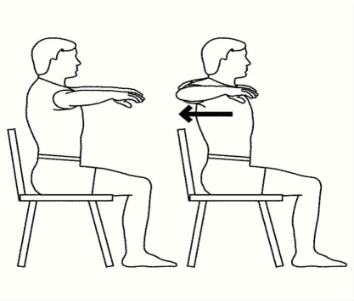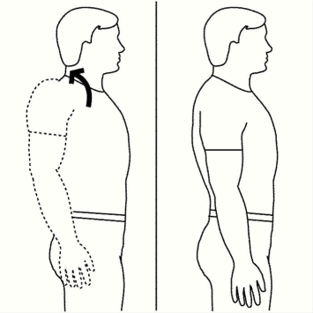
Perform 1 set of 3 Repetitions, twice a day. Perform 1 set of 5 Repetitions, twice a day. Perform 1 set of 10 Repetitions, twice a day
Hold exercise for 15 Seconds. Hold exercise for 5 Seconds. Perform 1 repetition every 4 Seconds.

Stretch upper Trapezius Active Cervical Rotation
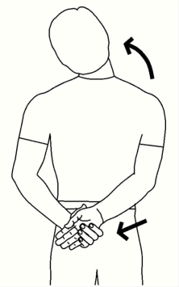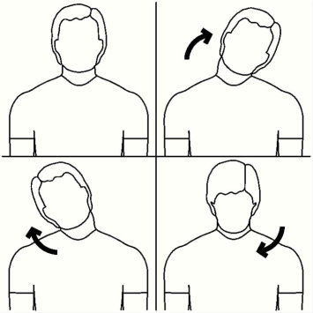
Perform 1 set of 2 Repetitions, twice a day Perform 1 set of 5 Repetitions, twice a day.
Hold exercise for 20 Seconds. Perform 1 repetition every 4 Seconds

